2014

Justin Dearham & Graham Gilbert

210146249 & 200714392

10/15/2014

User Guide



Table of Contents

Table of Contents 1

System Overview 3

Requirements and Installation 3

Hardware and Software Requirements 3

System updates 3

Working with Multiple Users 3

Administrator Operational Manual 3

System Overview Diagram 4

Assumed Background 4

Database information 4

Entity relationship diagram 5

Design and look and feel 6

Other resources 6

Users Operational Manual 6

Add new Vehicle 6

Add new Customer 8

9

Add new Salesman 10

Make a Sale New Client 12

13

Make sale existing client 16

View stock by status 22

Problems and solutions 24

Login problems 24

Time-out problem 25

# System Overview

SalesPlatform is a modular Sales application that can be customized for various business needs.

The system will allow for adding products to the system and allowing a salesman to sell the product to a customer. This in turn keeps record of sale, customer detail, salesman total sales and stock levels.

This version of SalesPlatform is specific to a small business that trades vehicles. From this point forward we refer to it as “SalesPlatform-Auto”.

SalesPlatform-Auto is a web based multi-user application build with the latest version of .NET and SQL server 2014.

This product was designed with the end-user in mind and has purposefully been designed to be extremely simple. Multi Platforms are supported. The system is easily modified and a system administrator should have no problems changing formats and adding any information that the business requires. The base program has been set up to be very flexible.

## Requirements and Installation

### Hardware and Software Requirements

The system is accessible from any device that has authorized access to the network where SalesPlatform-Auto is hosted. It is however recommended that the latest version of your web Brower is used.

The system works optimally with SQL Server 2014 and Microsoft Internet Explorer 11 and above. The system has been tested in Google Chrome and Mozilla Firefox and is compatible with all the latest versions.

The source information is contained on the enclosed DVD and a soft copy of this documents is contained therein.

### System updates

Updates will be handled by the System Administrator. The System Administrator will be provided with FTP access to the latest system updates directly from the designers.

### Working with Multiple Users

The application is multi-user compatible. However it depends on the platform it is deployed on and also the load capacity. The optimum recommended users are 6 at the same time.

## Administrator Operational Manual

This is the source of information for the system administrator.

The system architecture is based on a 2-tier system, client – webserver. The administrator will have full rights to the system and is able to debug the system as required. The administrator is required to have a working knowledge of the .NET framework and should be familiar with SQL commands.

### System Overview Diagram

Database

Internet

IIS Service

SERVER

Firewall

### Assumed Background

Has extensive knowledge of managing web based applications. Knowledge of the .Net framework will be an added advantage and will decrease the learning curve.

### Database information

All information is stored in a SQL Server 2014 database which is located in the **App_Data** Folder as below. The default name is “**SalesPlat-Auto.md**f”.

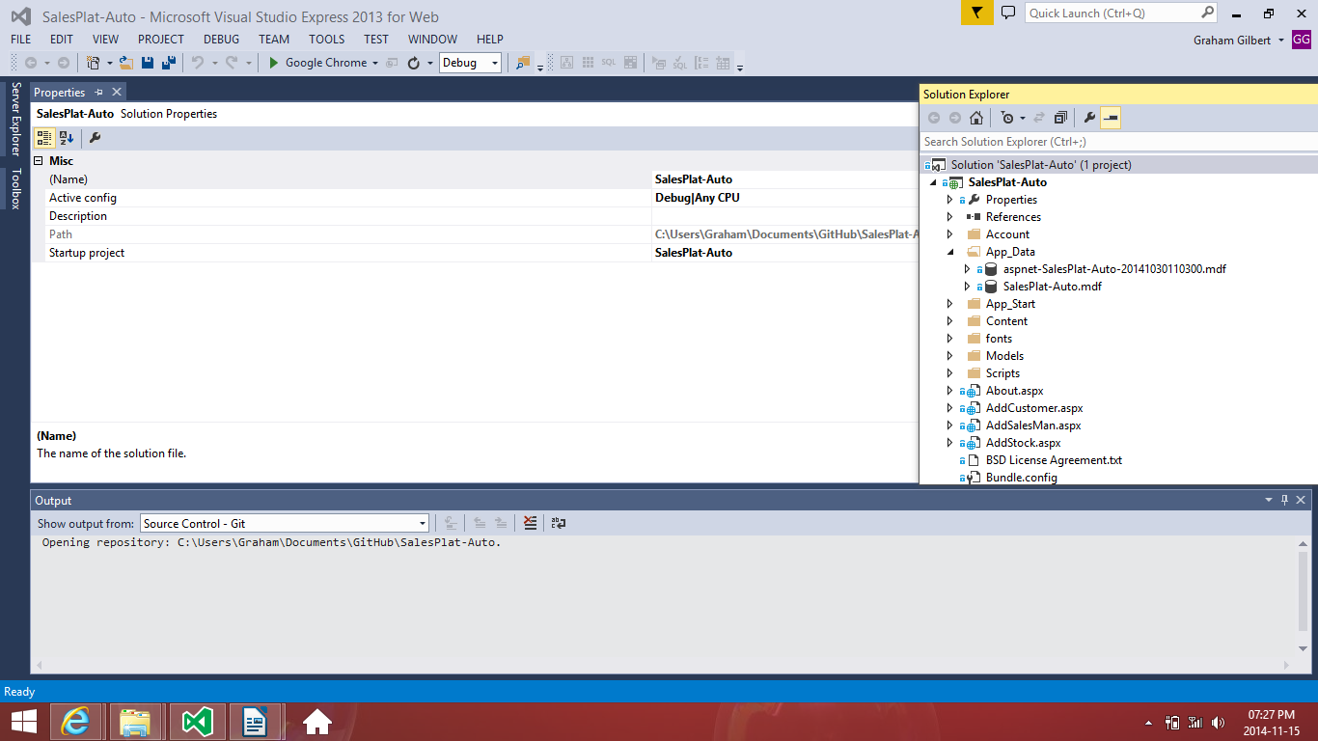

### Entity relationship diagram

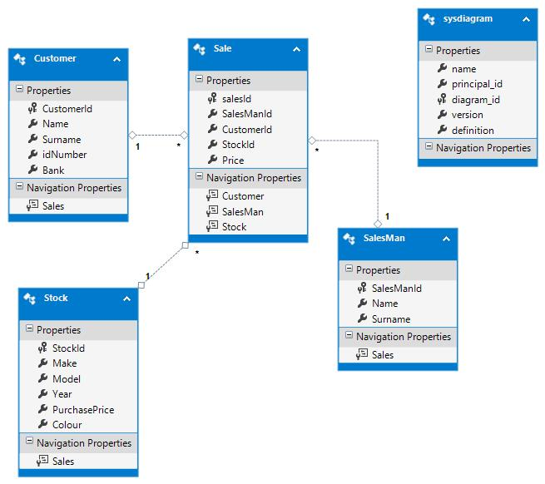

### Design and look and feel

The default platform purposefully comes with a clean and uncluttered look. However the theme can be changed at anytime with updated CSS/JS files from the bootstrap collection. Visual studio 2013 has a built-in functionality for this located in the **Scripts** and **Content** folders per below.

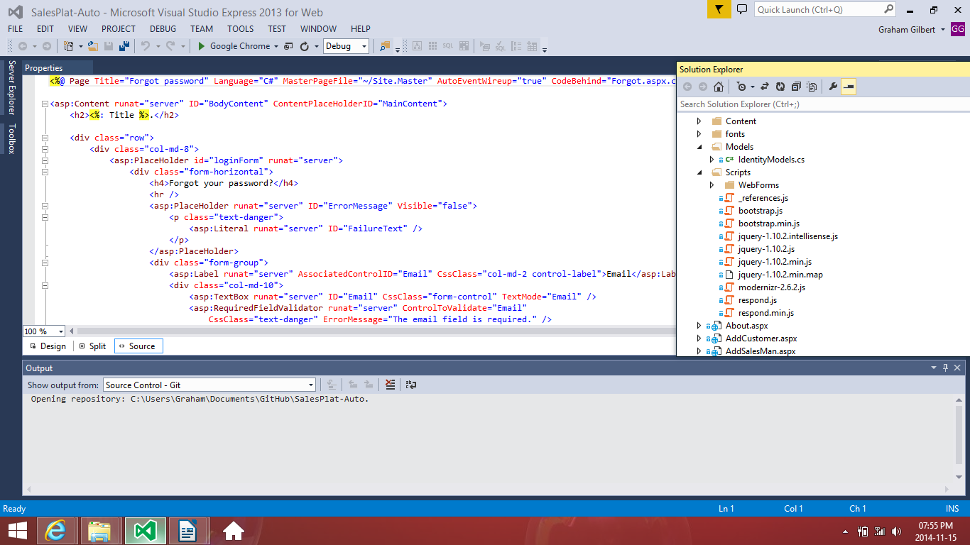

### Other resources

1. Getbootsrap.com<http://getbootstrap.com/>
2. Www.dearhamgilbert.com[http://www.dearhamgilbert.com](http://www.dearhamgilbert.com/)
3. <http://msdn.microsoft.com/en-us/library/dd831853.aspx>

## Users Operational Manual

### 

### Add new Vehicle

**Step 1:** Left click on "Home Page - Sales Platform Auto (button)"



**Step 2:** left click on "Add Stock in "Home Page - Sales Platform Auto

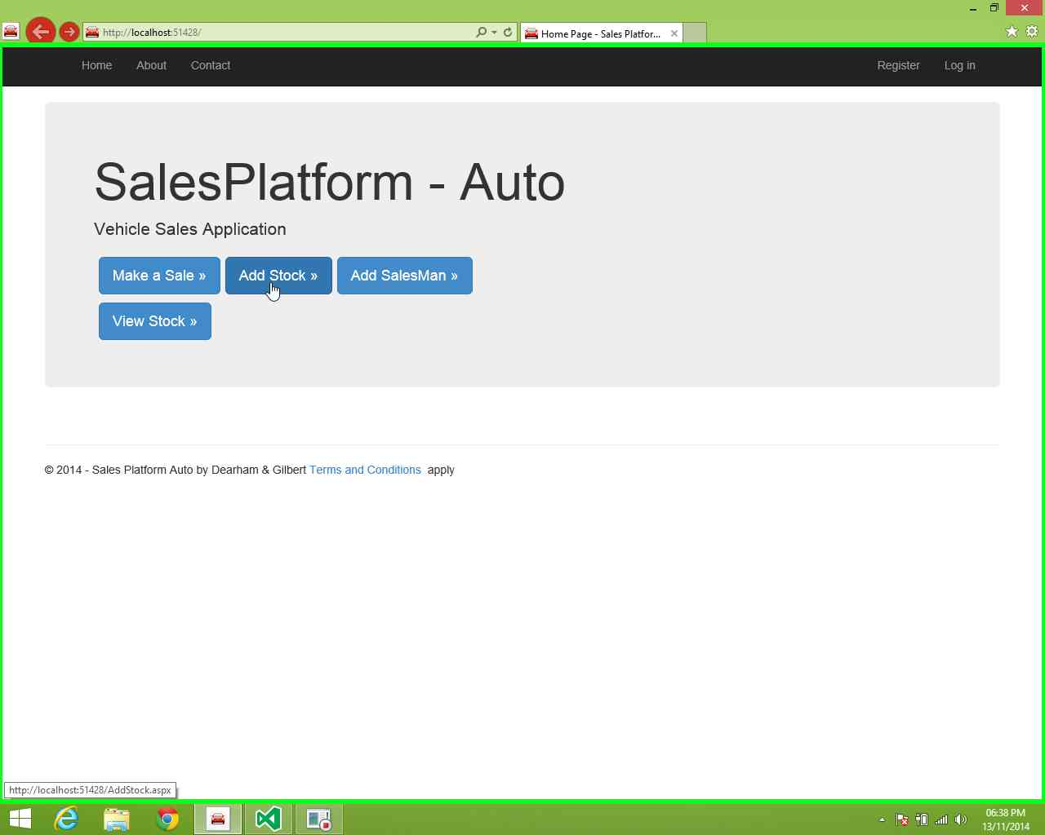

**Step 3:** left click in "- Sales Platform Auto - Home Page

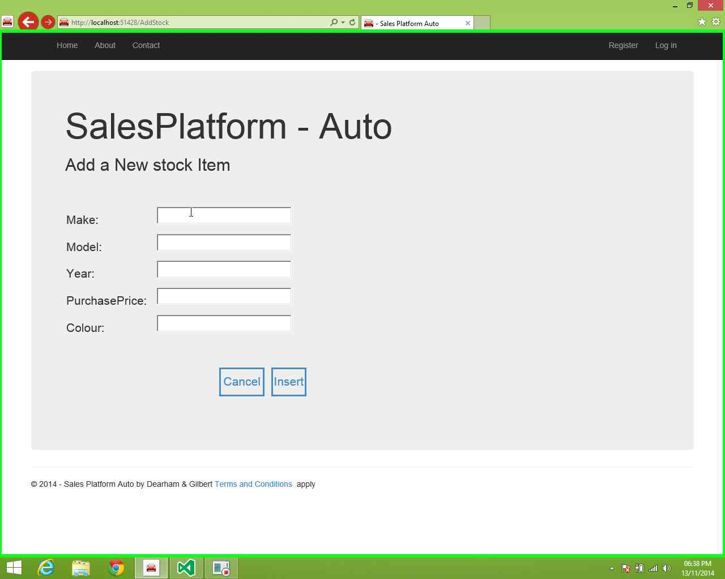

**Step 4:** Use keyboard input on web form to capture needed Details

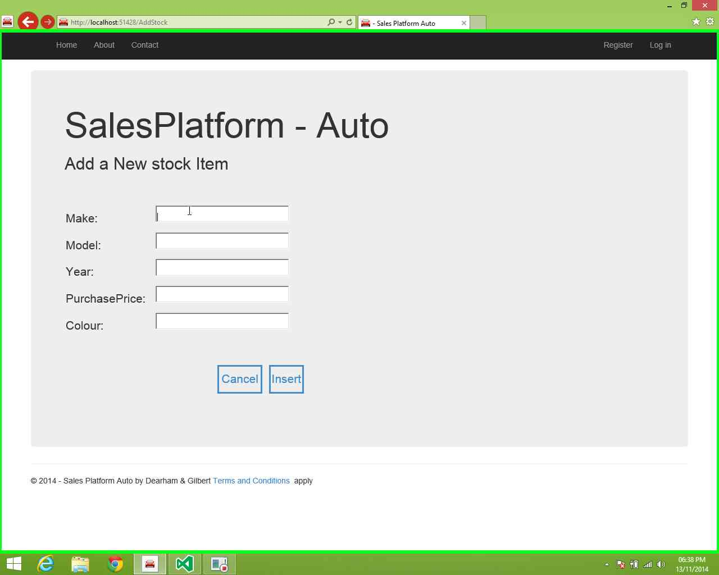

**Step 5:** left click on "- Insert in Sales Platform Auto – Home

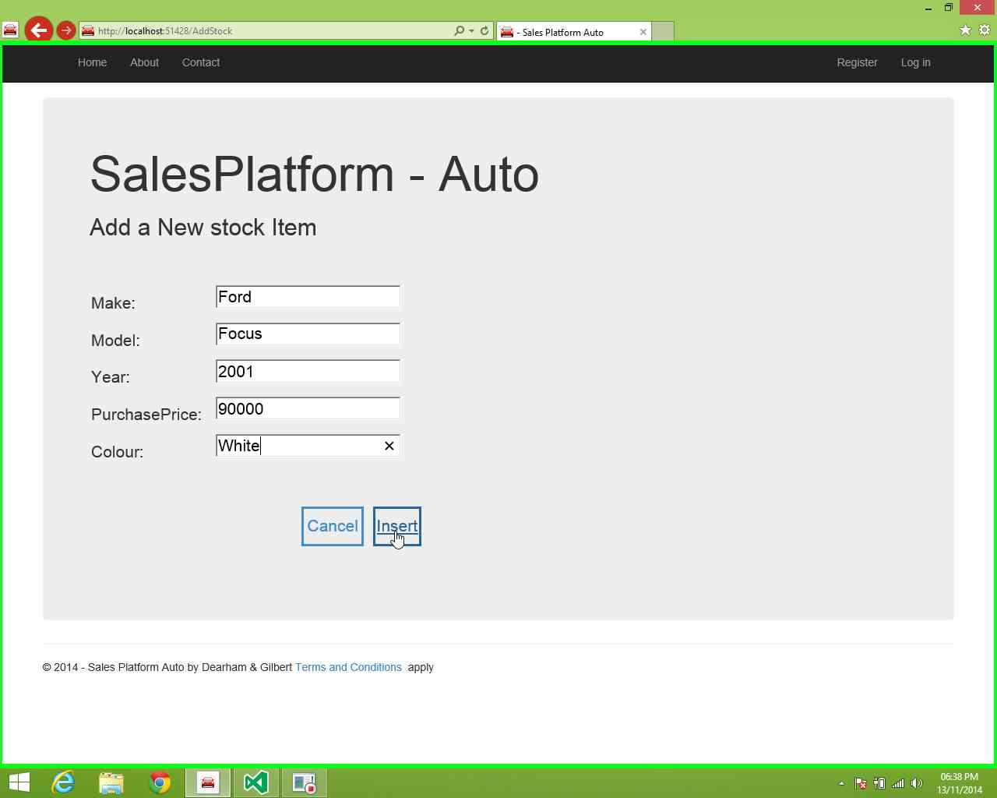

## Add new Customer

**Step 1:** Left click on "Home Page - Sales Platform Auto (button)"



**Step 2** left click on "Make a Sale “ in "Home Page - Sales Platform Auto

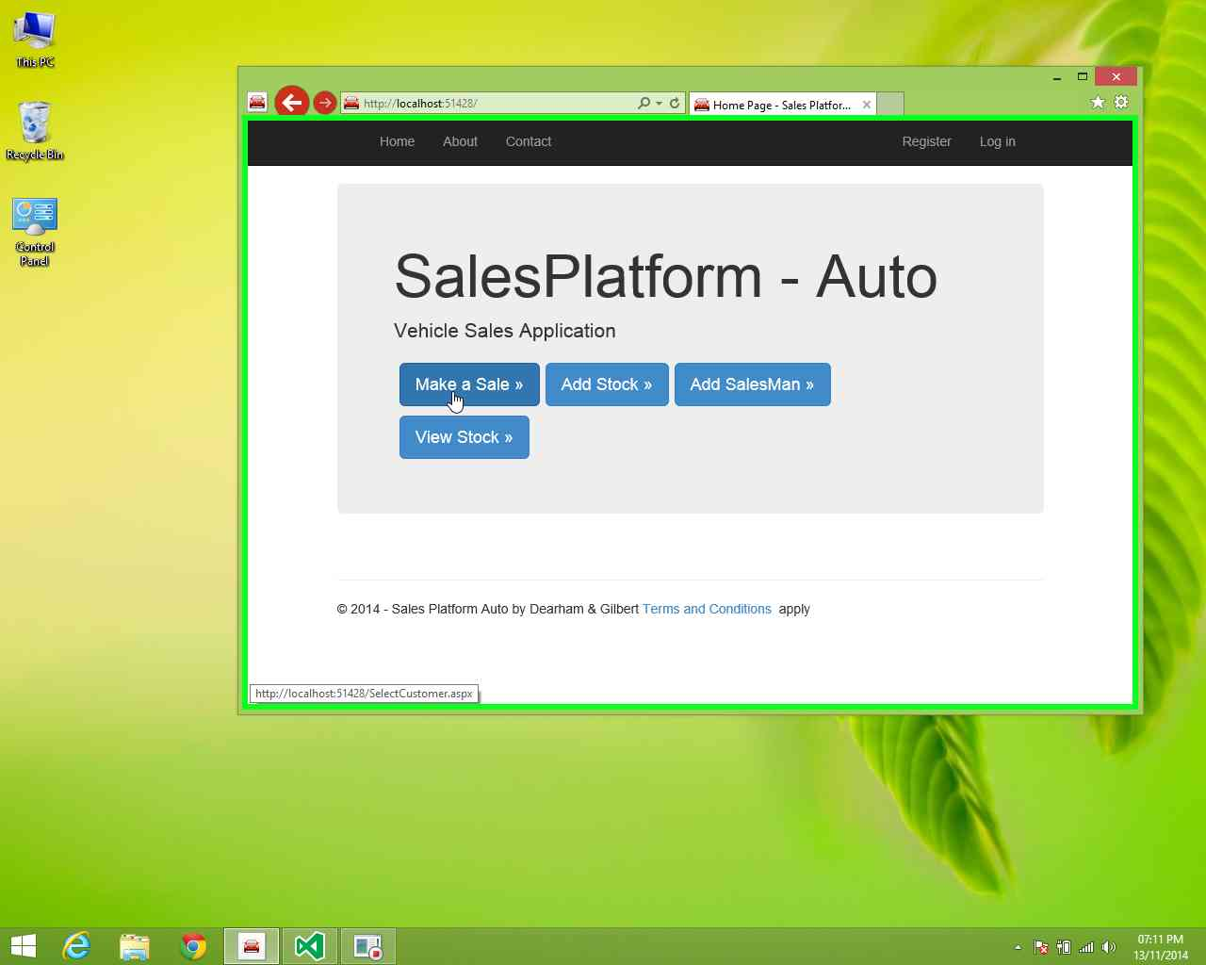

**Step 3:** left click on "New Customer (text)" in "- Sales Platform Auto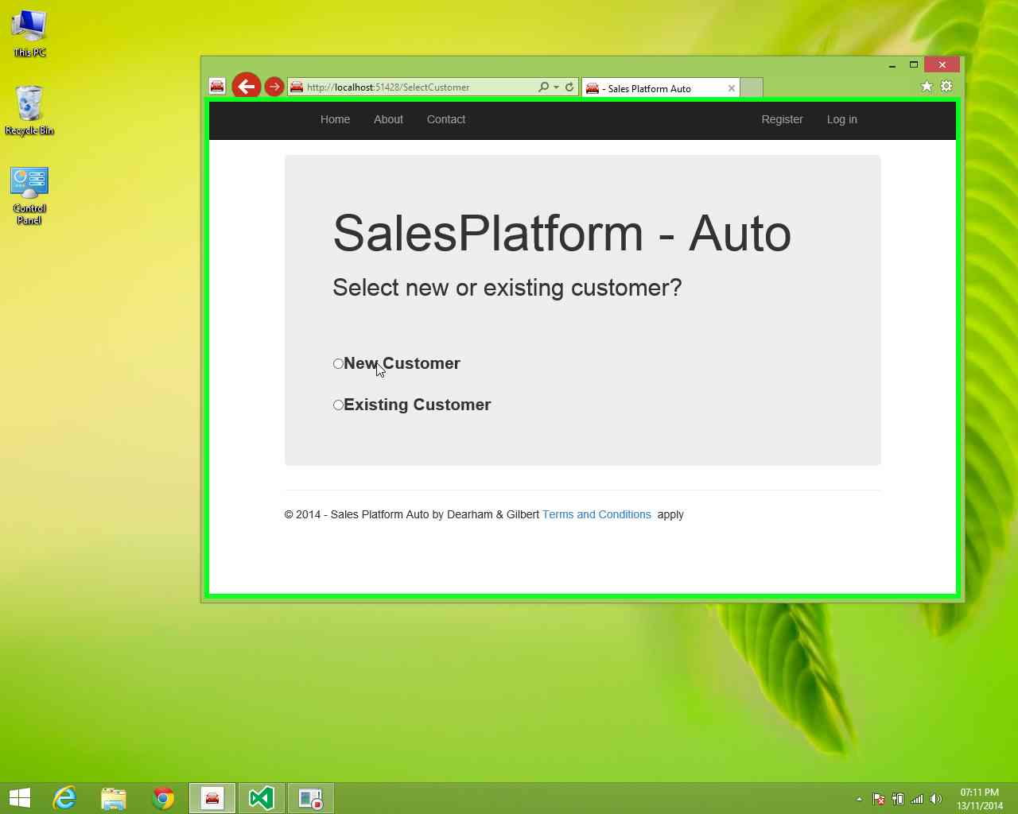

**Step 4:** left click in "- Sales Platform Auto - Home Page

## mhtml:file://C:\Users\jdearham\AppData\Local\Microsoft\UAR\Recording.mht!screenshot0004.JPEG

**Step 5:** Use Keyboard input to capture details" in "- Sales Platform Auto

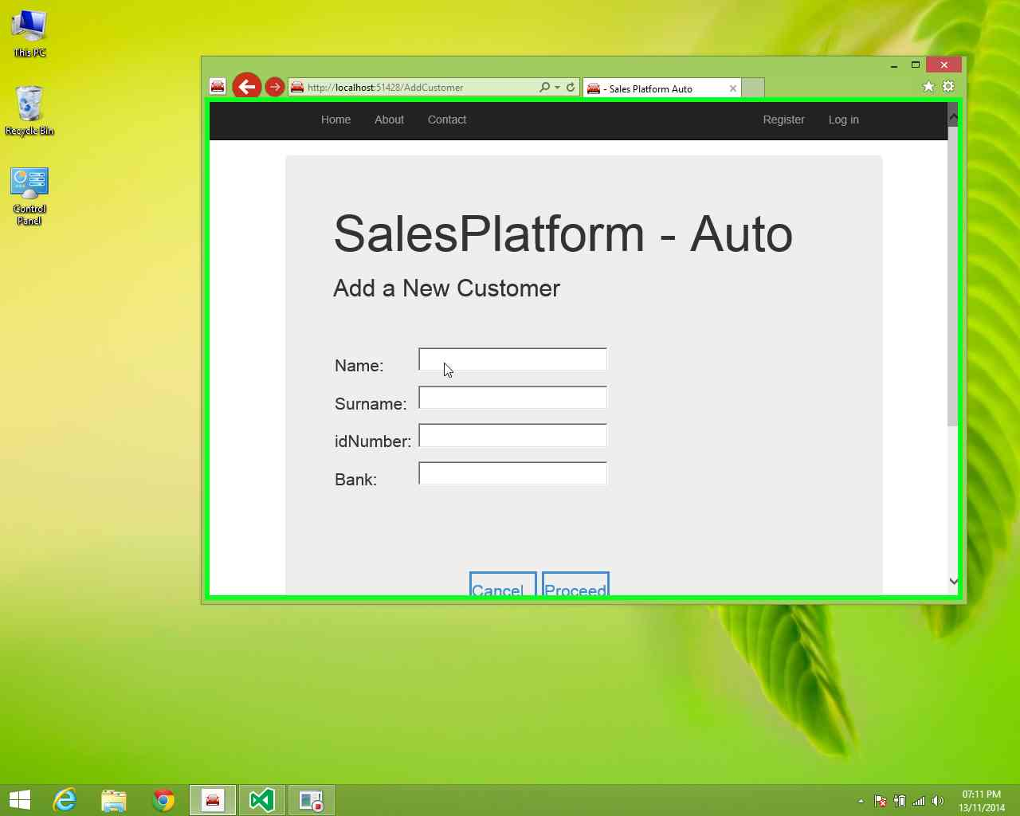

## Add new Salesman

**Step 1:** User left click on "Home Page - Sales Platform Auto (button)"



**Step 2:** left click on "Add SalesMan in "Home Page - Sales Platform Auto

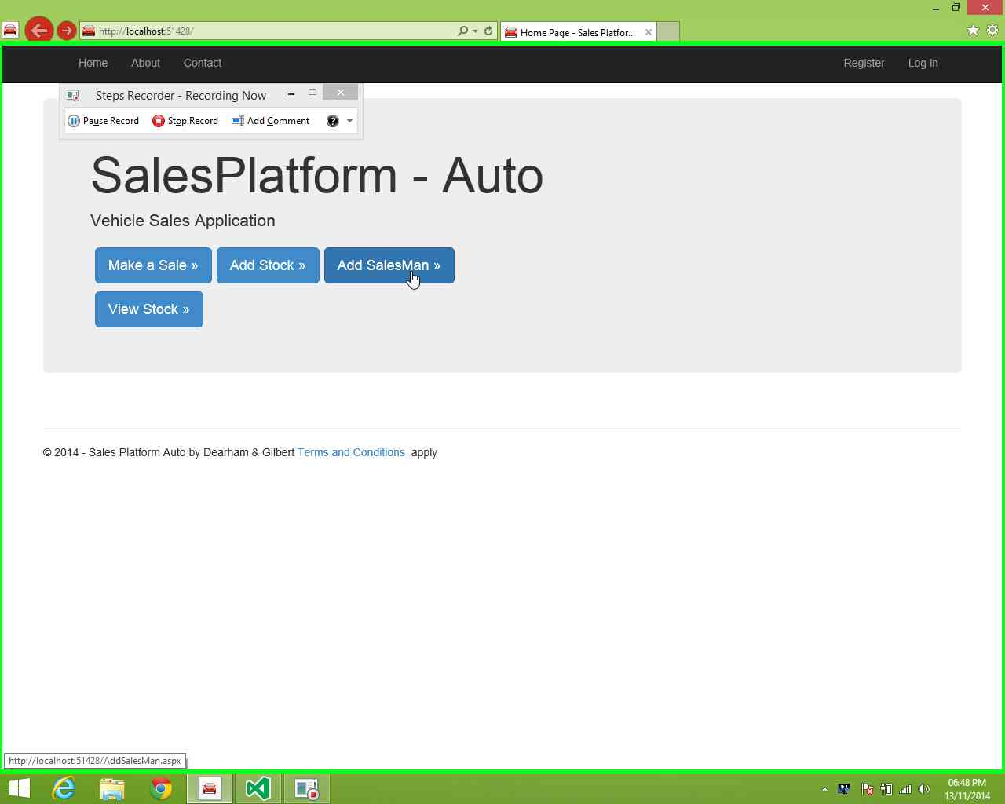

**Step 3:** left click in "- Sales Platform Auto - Home Page

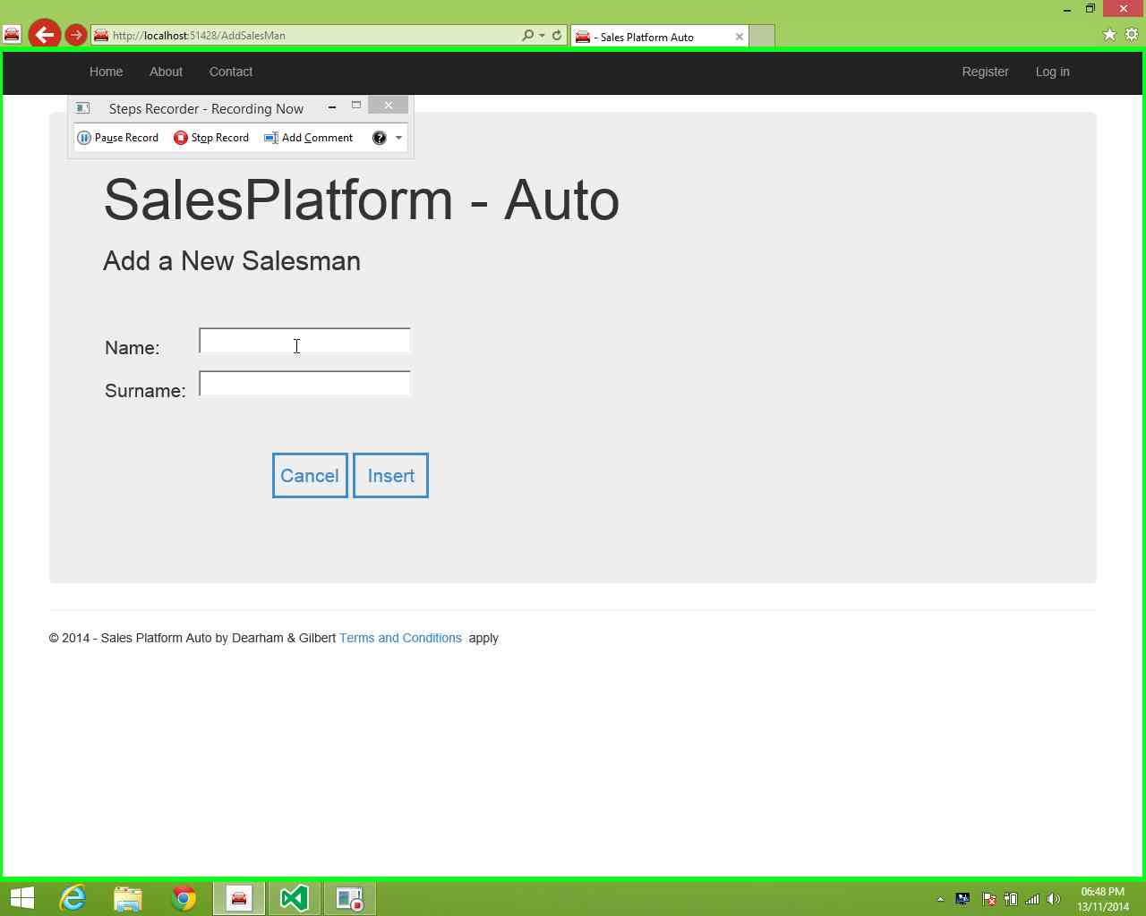

**Step 4:** Use Keyboard to input needed Details

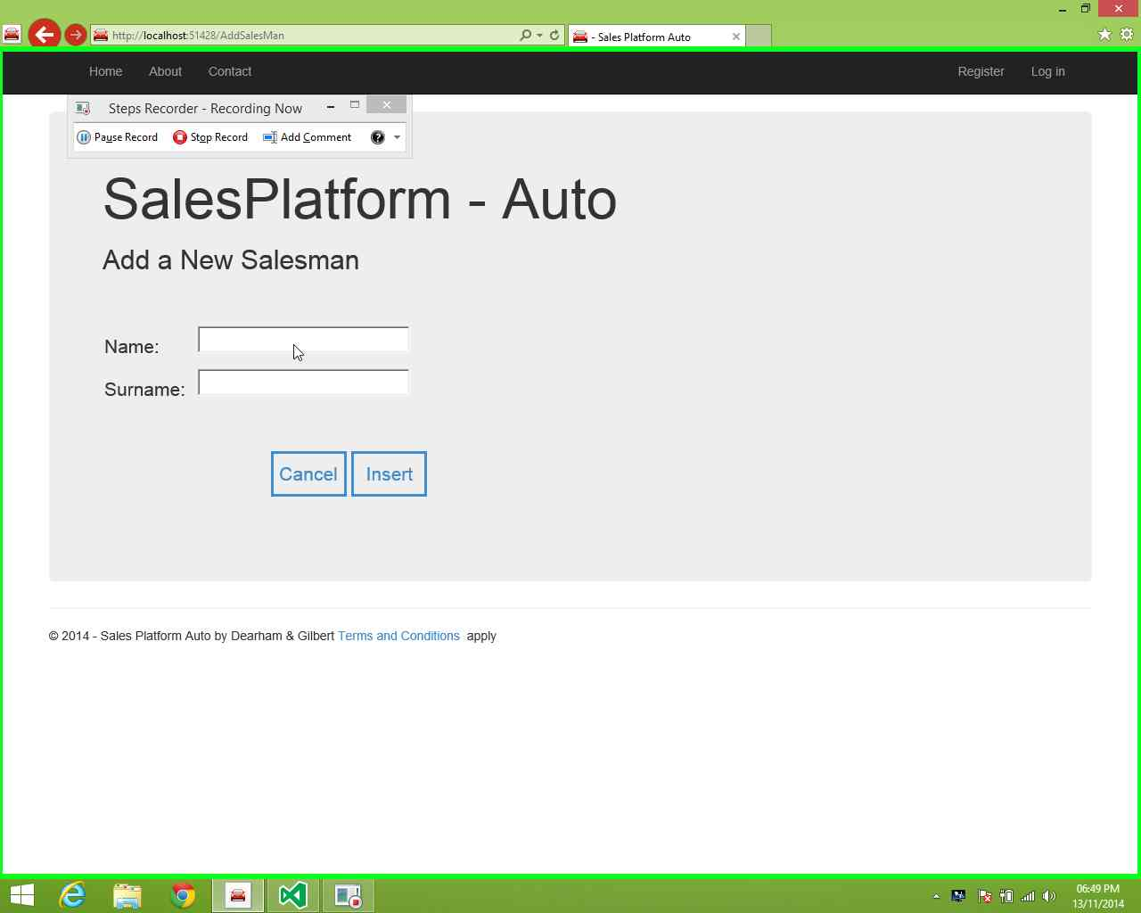

**Step 5:** Left click on Insert in Sales Platform Auto

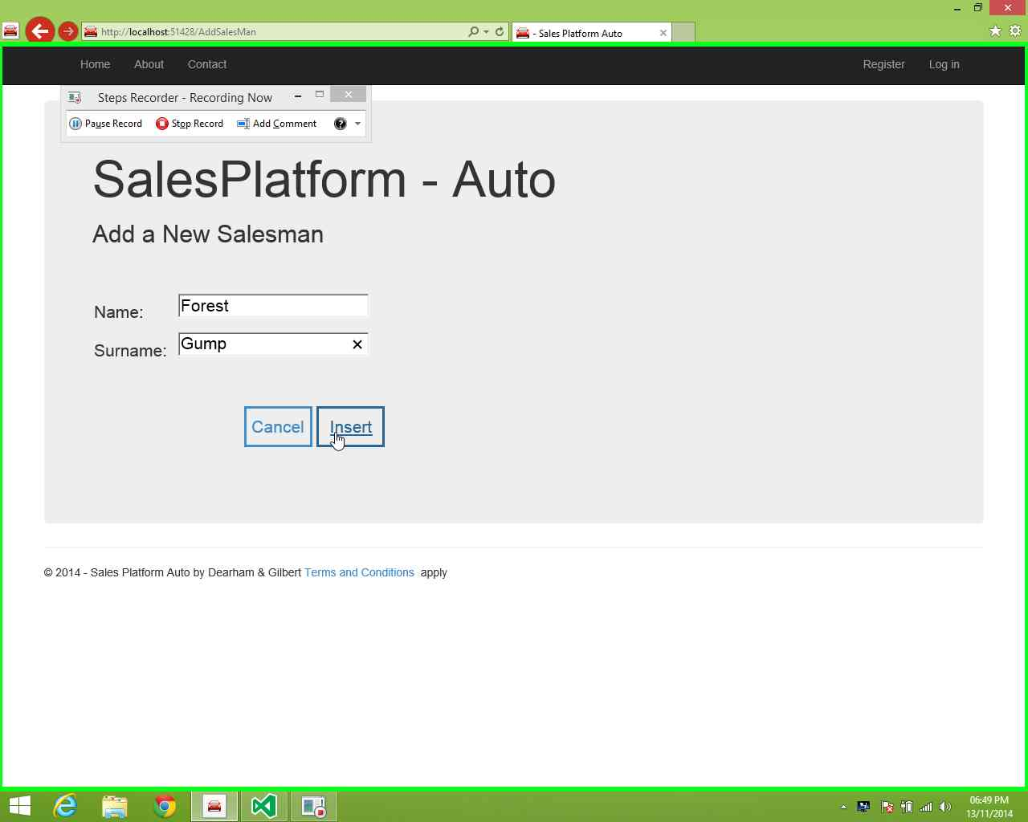

## Make a Sale New Client

**Step 1:** left click on "Home Page - Sales Platform



**Step 2** left click on "Make a Sale “ in "Home Page - Sales Platform Auto



**Step 3:** left click on "New Customer (text)" in "- Sales Platform Auto



**Step 4:** left click in "- Sales Platform Auto - Home Page

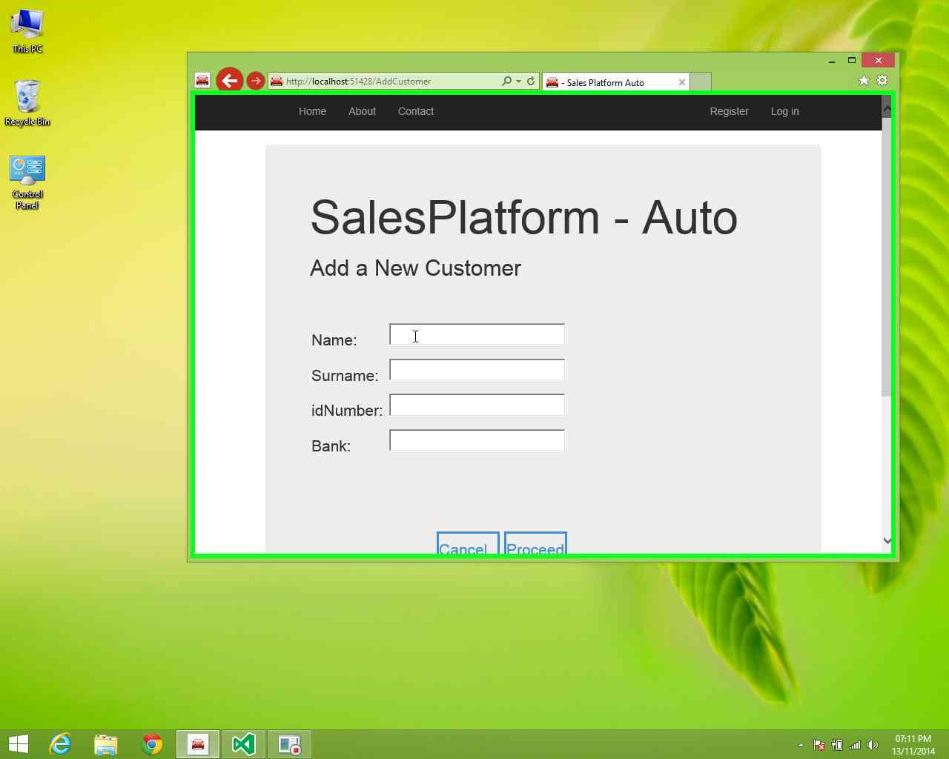

**Step 5:** Use Keyboard input to capture details" in "- Sales Platform Auto

# 

**Step 6:** left click on "Select (text) for added customer" in "- Sales Platform Auto

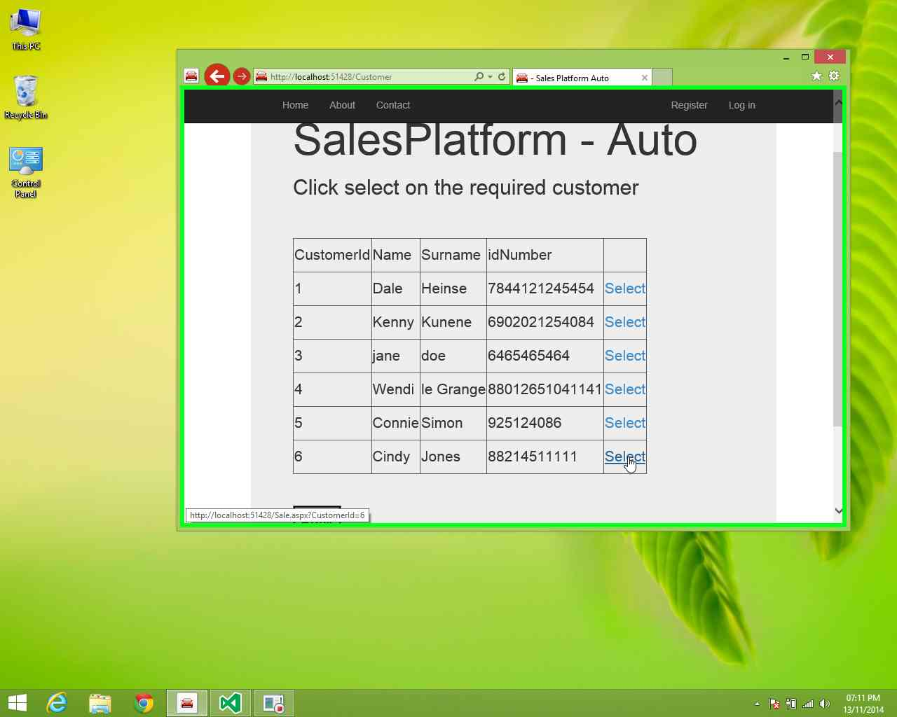

**Step 7:** left click on "Desired salesman (list item)"

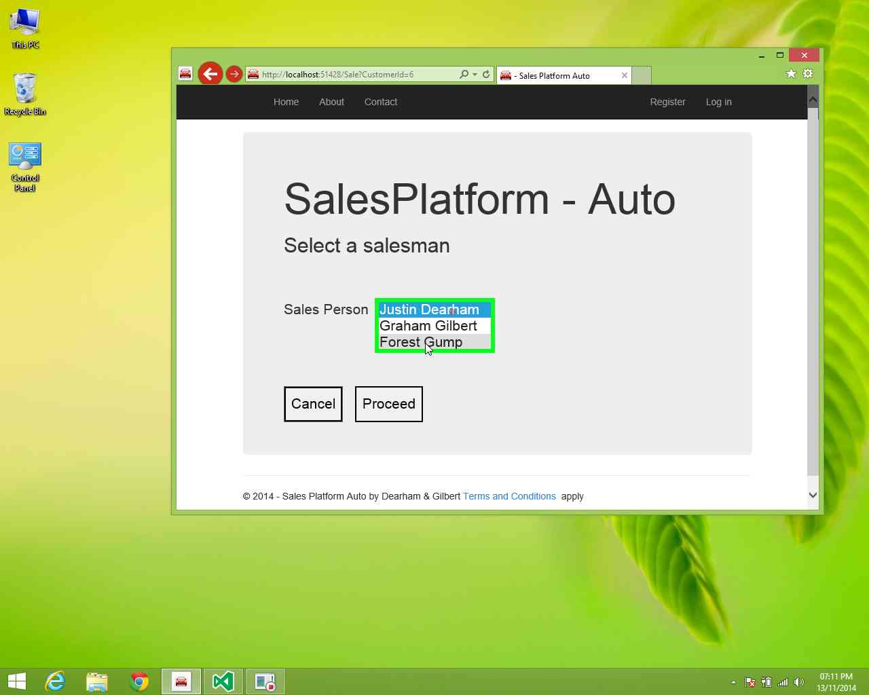

**Step 8:** left click on "Proceed (button)" in "- Sales Platform Auto

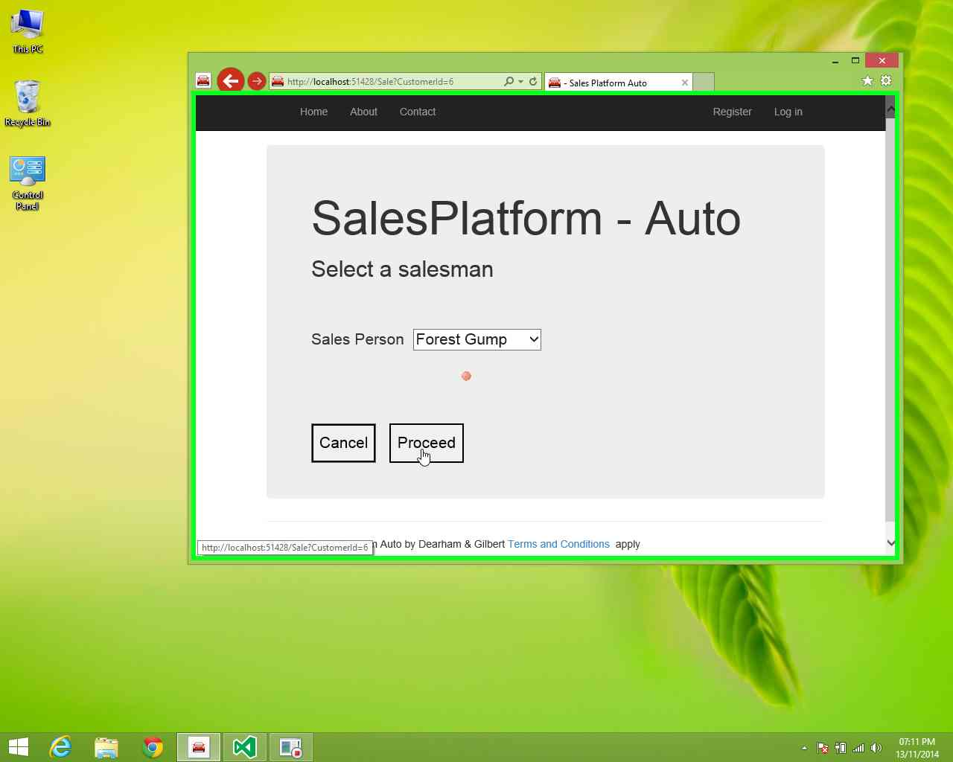

**Step 9:** Select a vehicle and left click on "Proceed (button)" in "- Sales Platform Auto

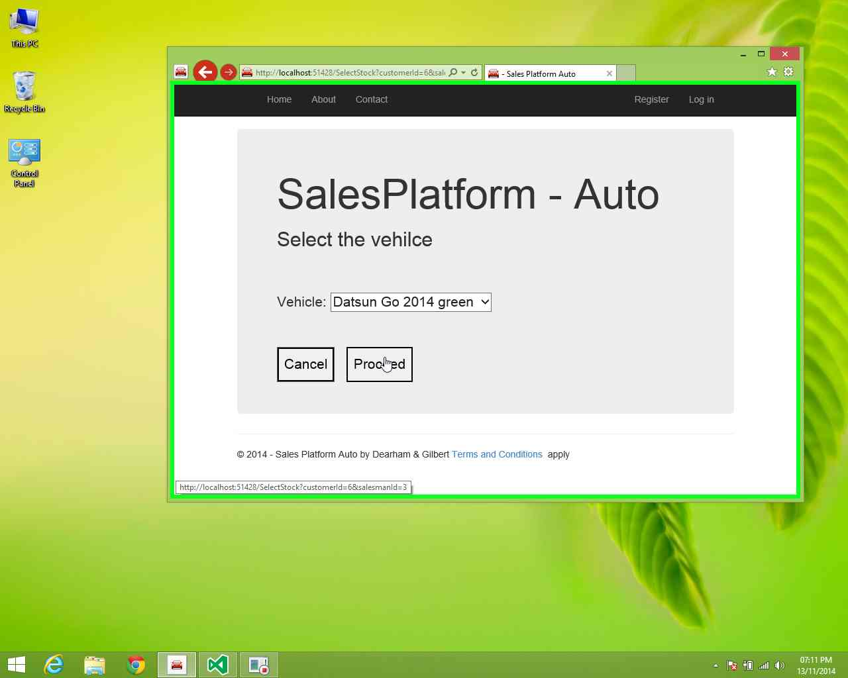

**Step 10:**  Use the keyboard to input price on Sales Platform Auto

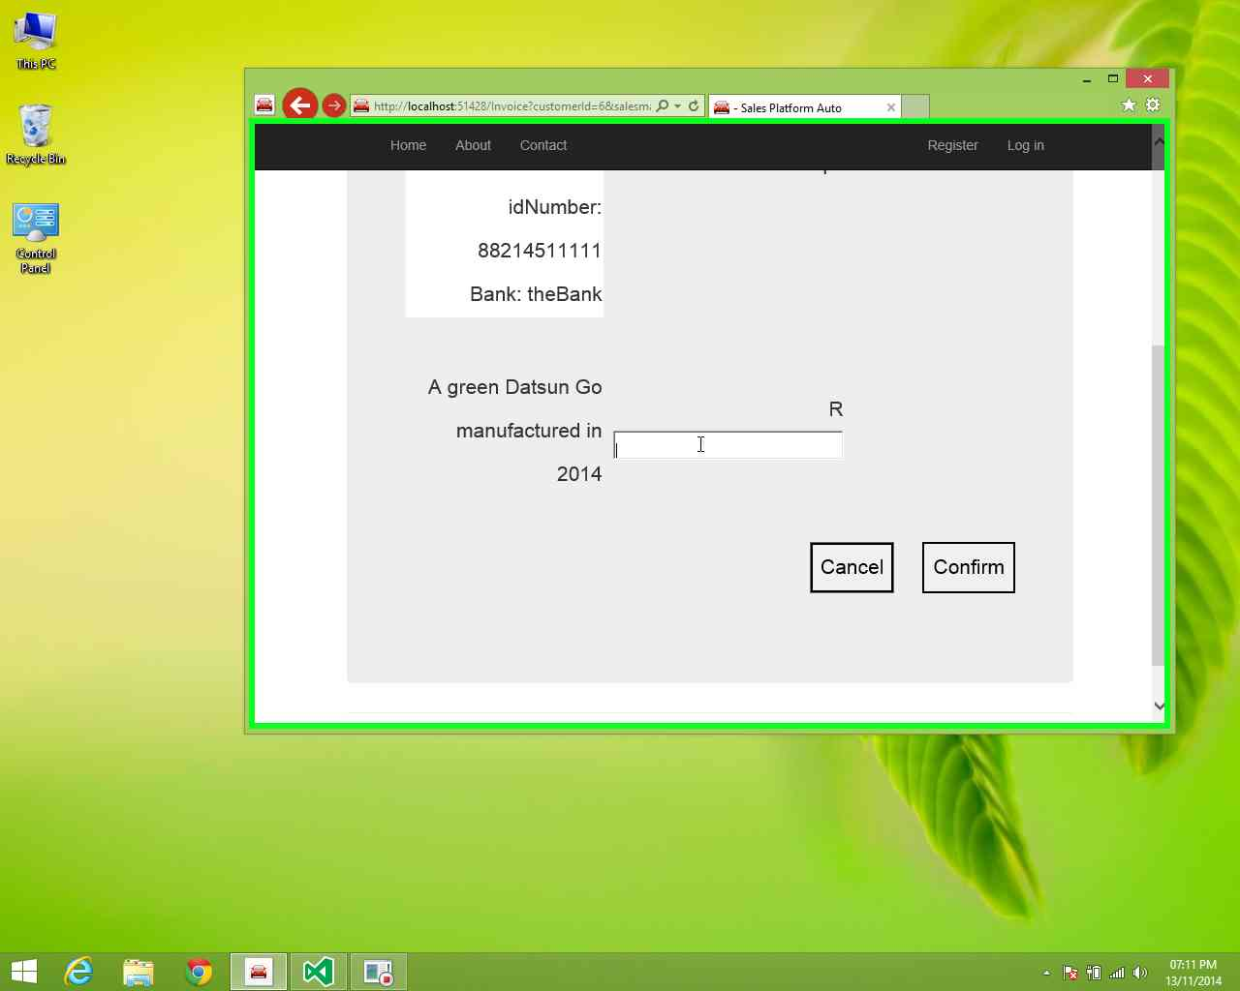

**Step 11:** left click on "Confirm (button)" in "- Sales Platform Auto

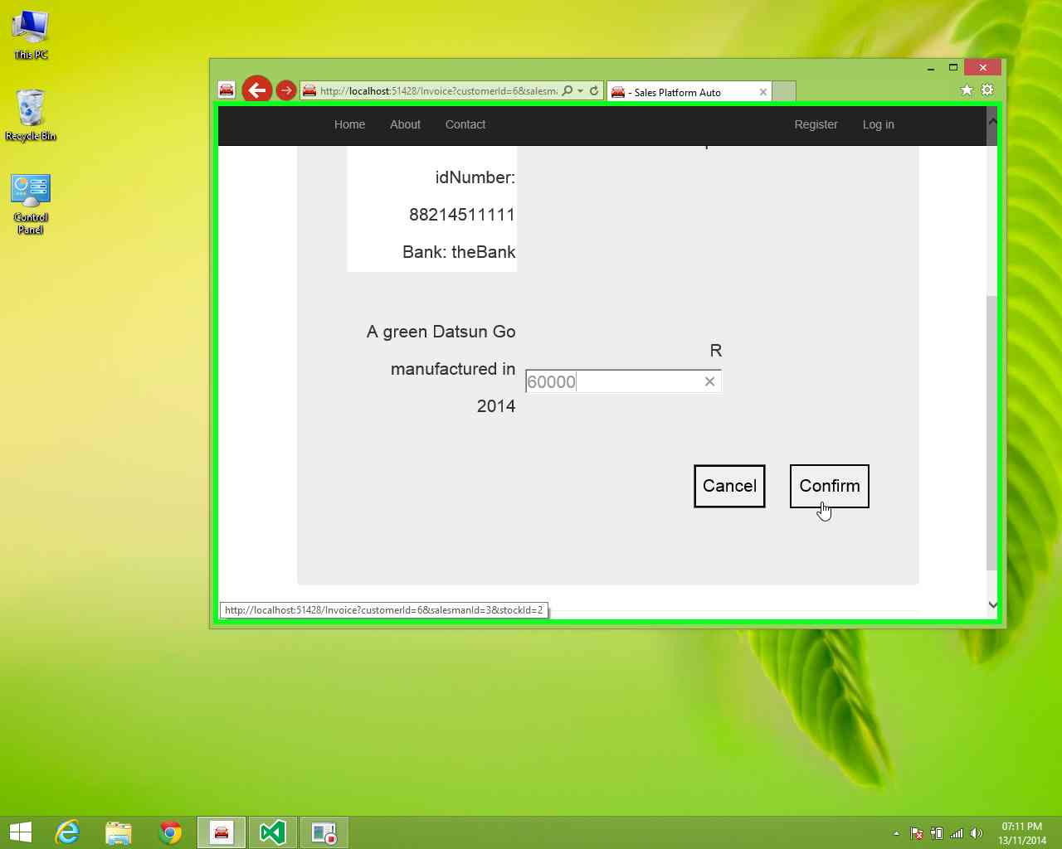

## Make sale existing client

**Step 1:** User left click on "Home Page - Sales Platform button



**Step 2:** left click on Make a in Home Page - Sales Platform Auto

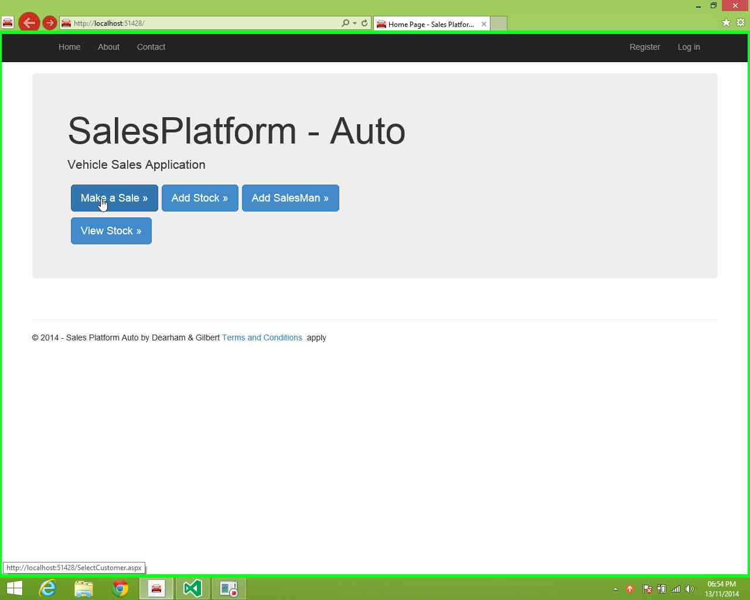

**Step 3** left click on "Existing Customer (radio button)" in "- Sales Platform Auto

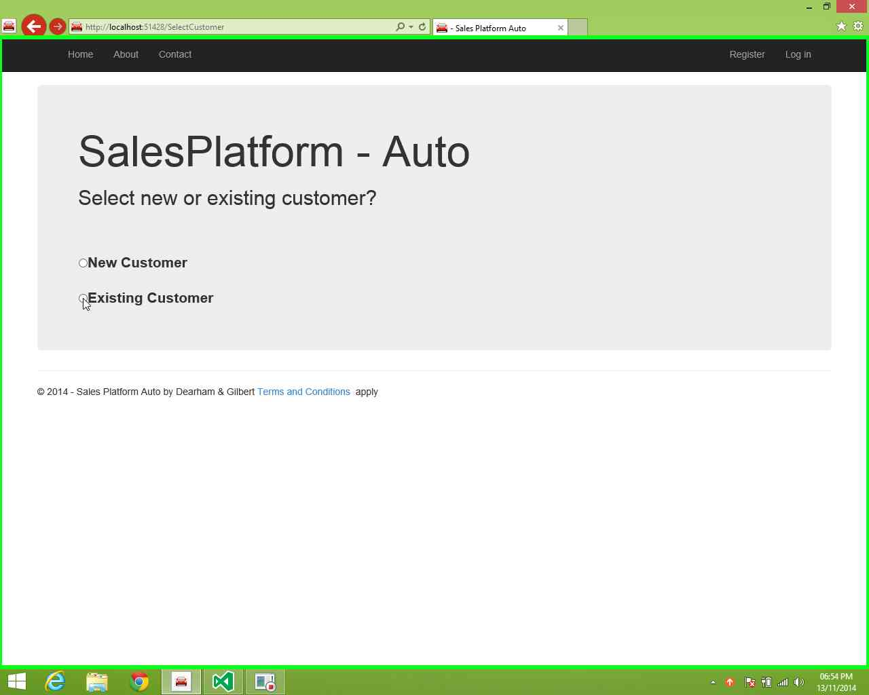

**Step 4** left click on "Select (text)" in "- Sales Platform Auto – Home

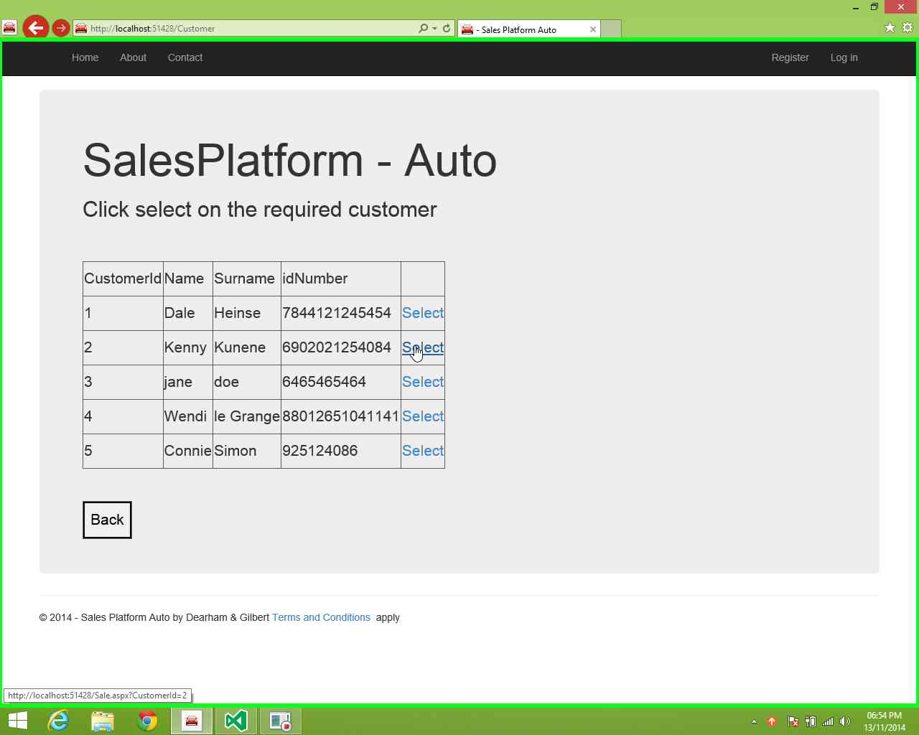

**Step 5:** left click on "Open (button)" in drop down on"- Sales Platform Auto

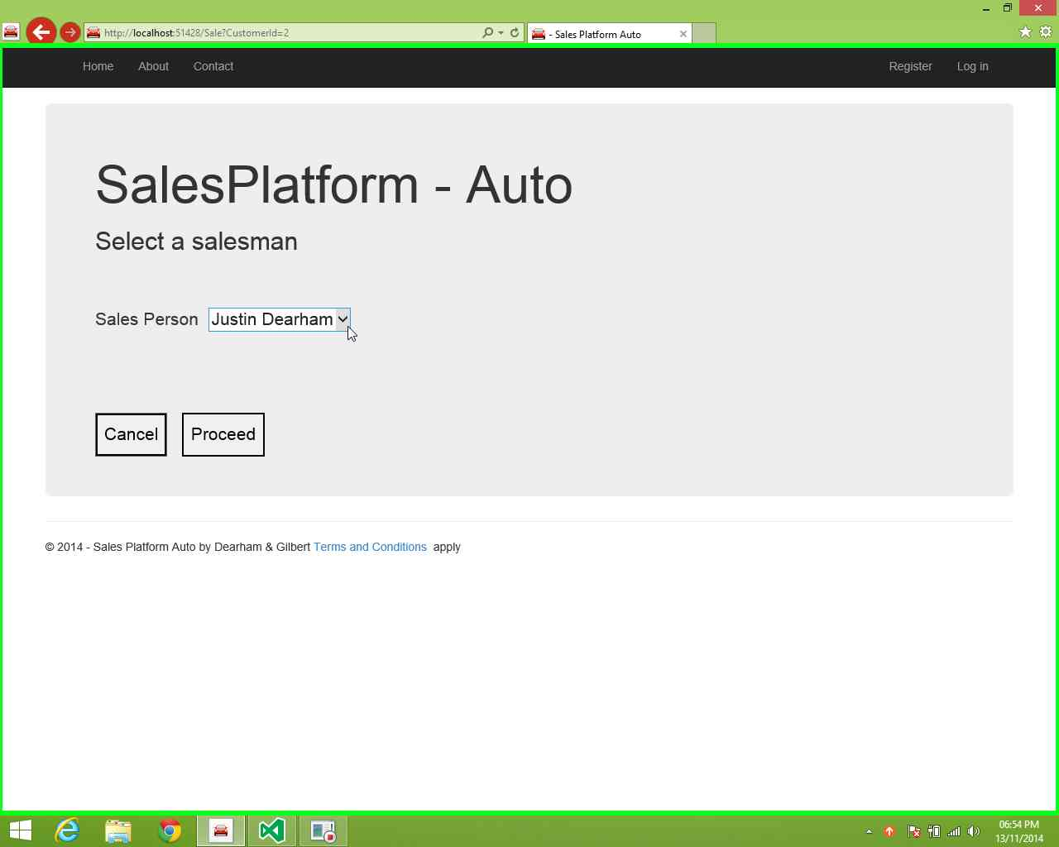

**Step 6:** left click on "Desired list item"

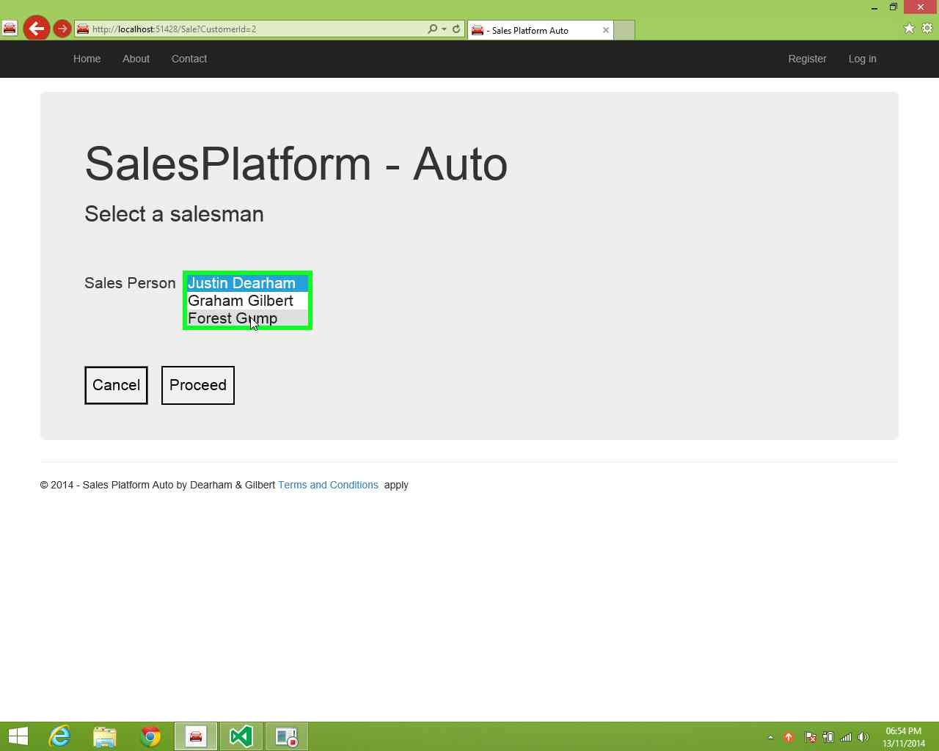

**Step 7:** left click on "Proceed (button)" in "- Sales Platform

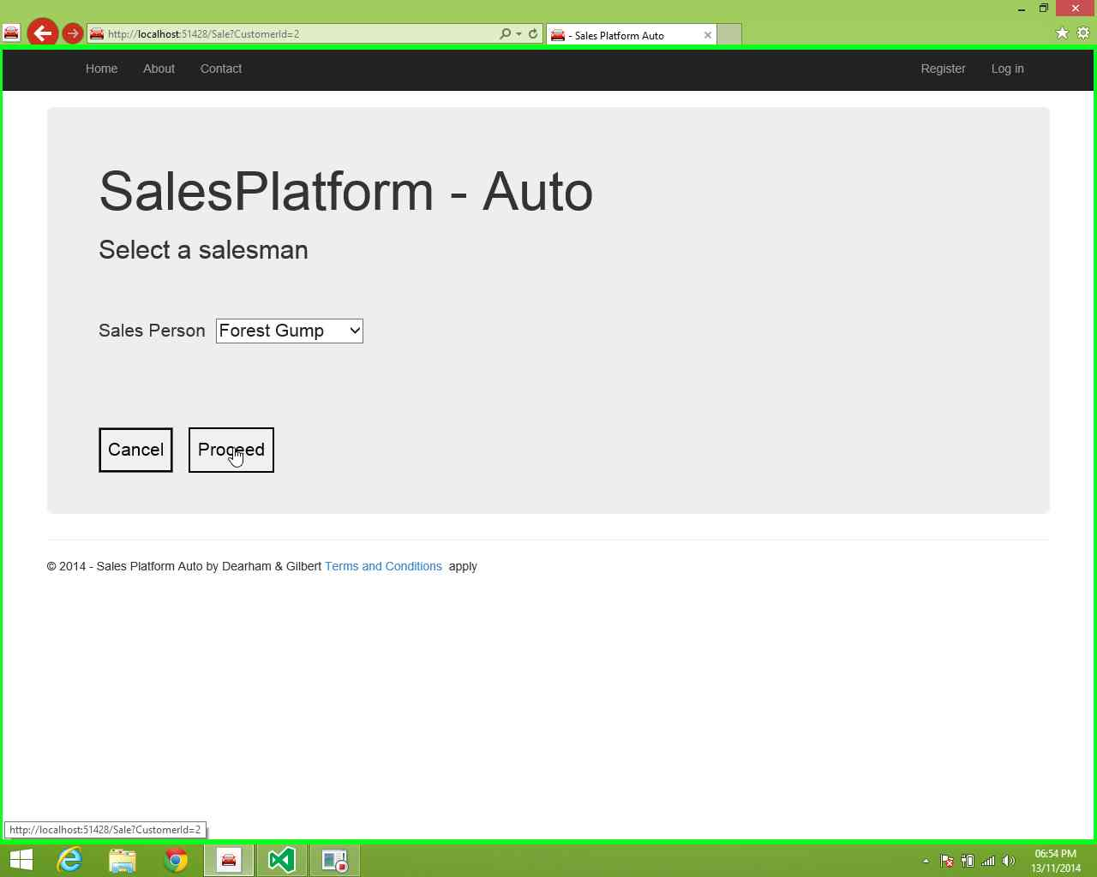

**Step 8:** left click on "- Sales Platform Auto (pane)" in "- Sales Platform Auto"

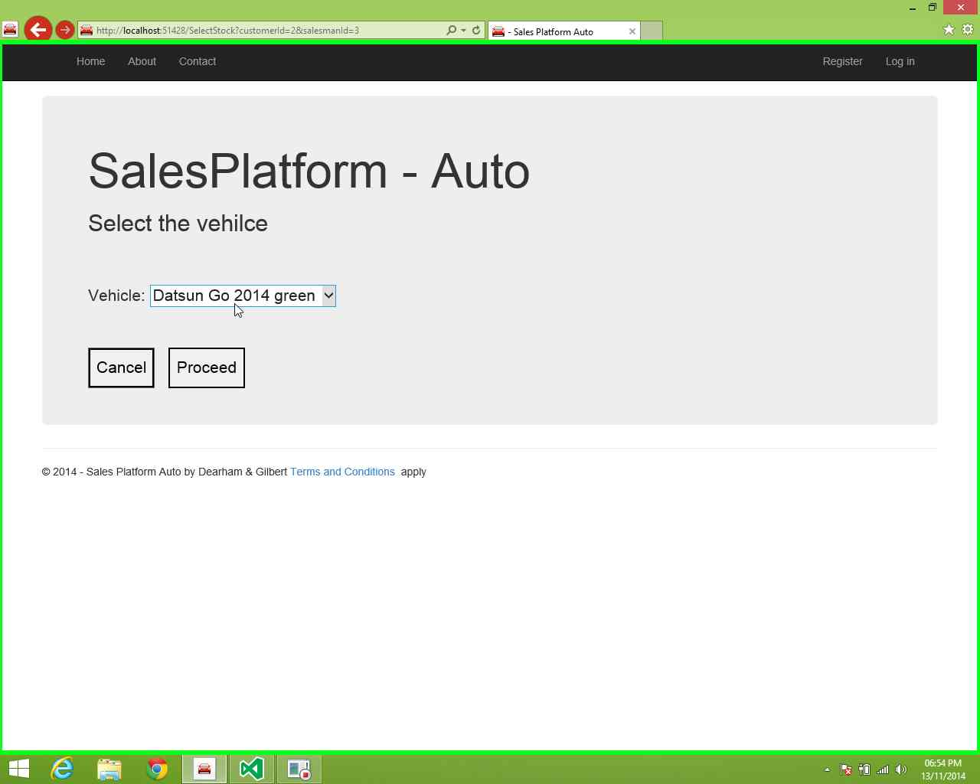

**Step 9:** left click on "Desired (list item)"

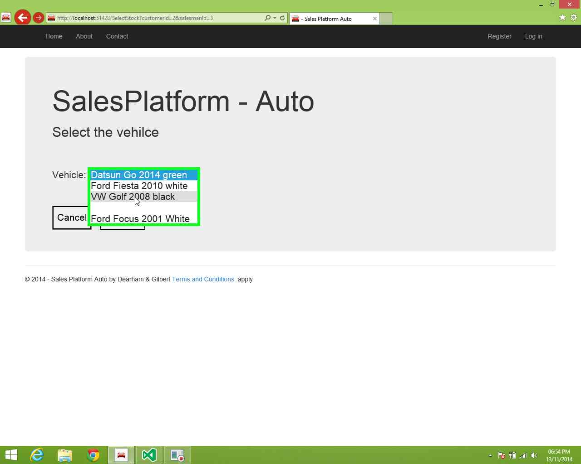

**Step 10:** left click on "Proceed (button)" in "- Sales Platform

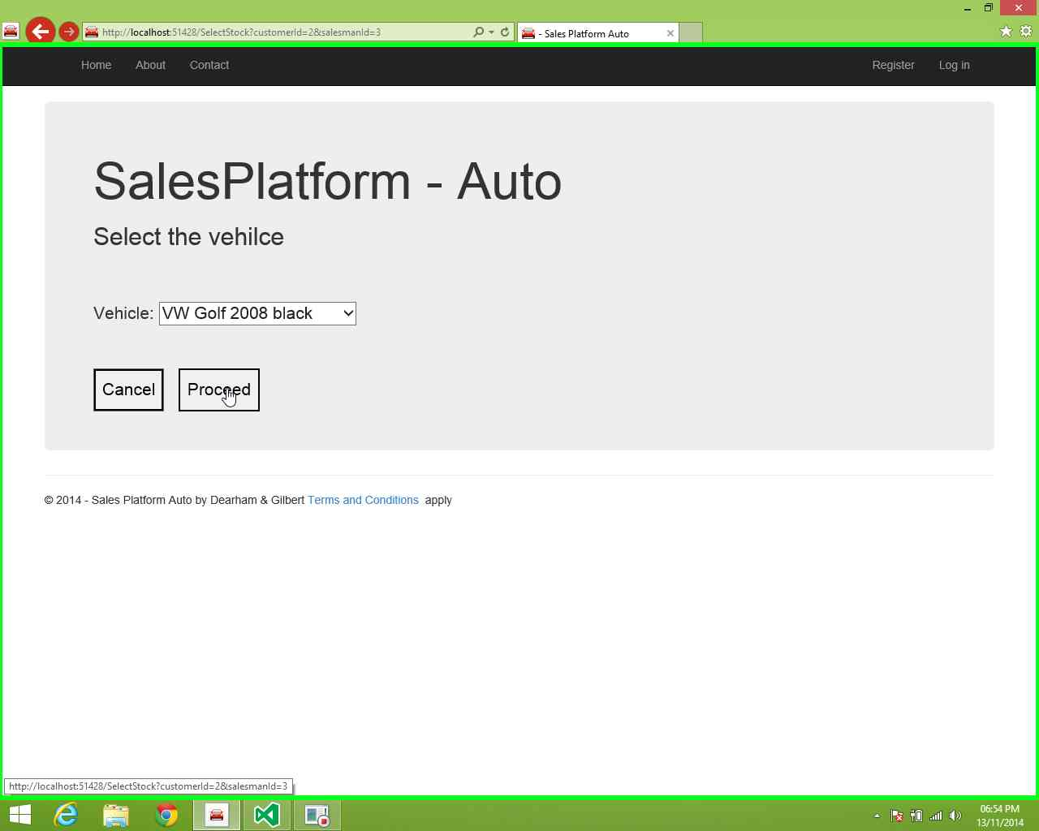

**Step 11:** left click on textbox and capture value on Sales Platform Auto"  
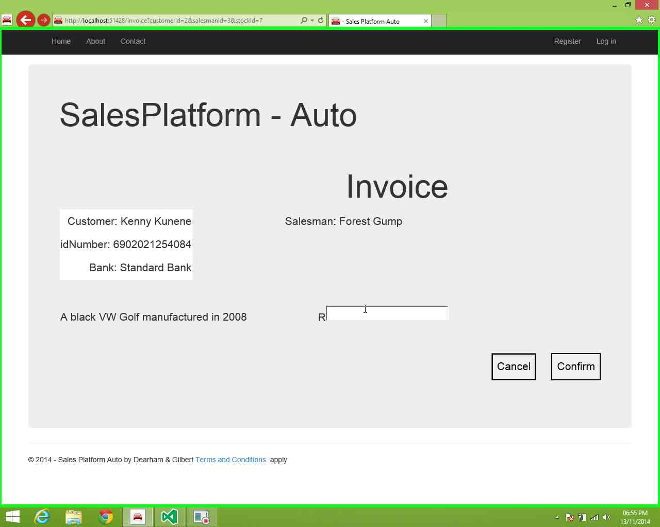

**Step 12:** left click on "Confirm (button)" in "- Sales Platform Auto

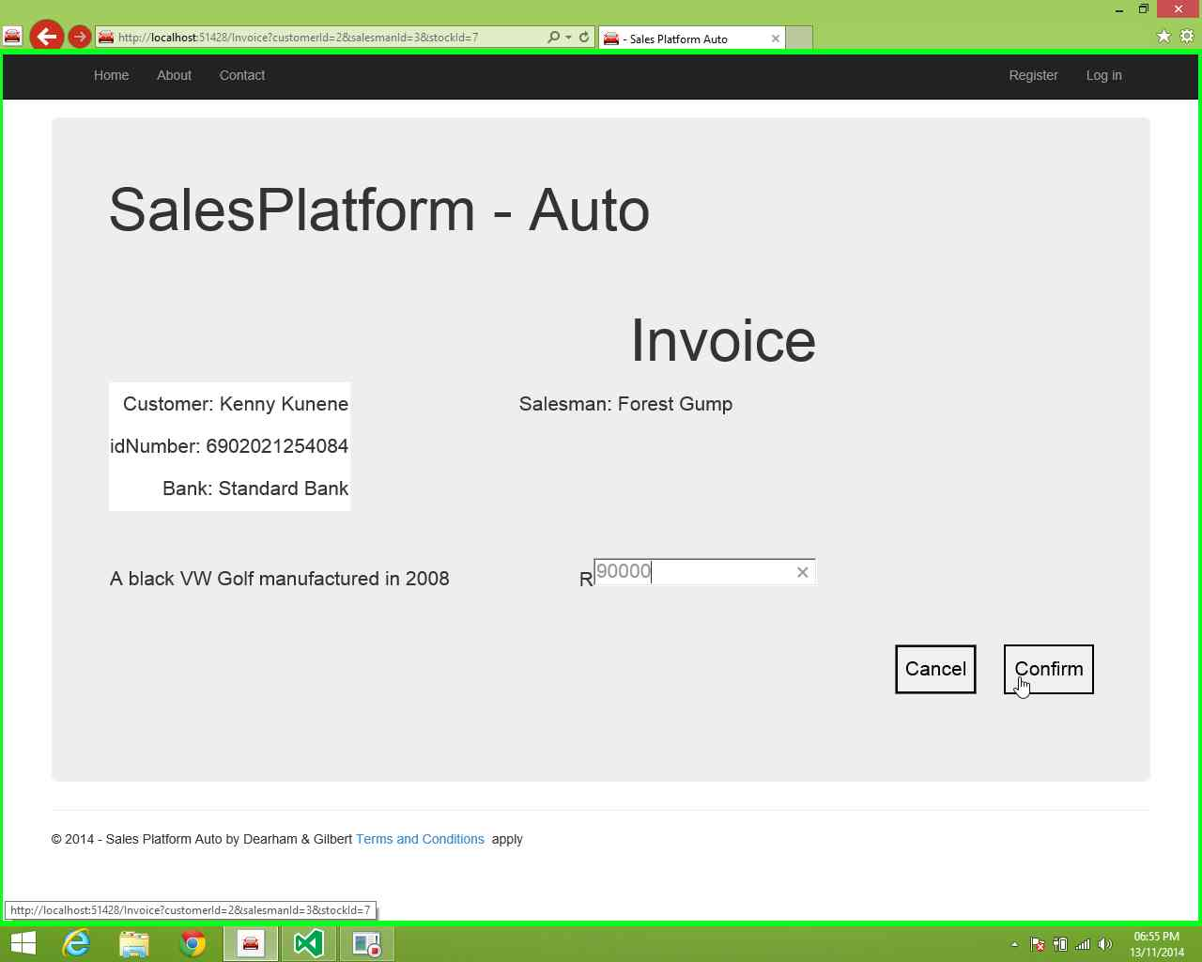

## View stock by status

**Step 1:** User left click on "Home Page - Sales Platform button



**Step 2:** left click on "View Stock in "Home Page - Sales Platform Auto

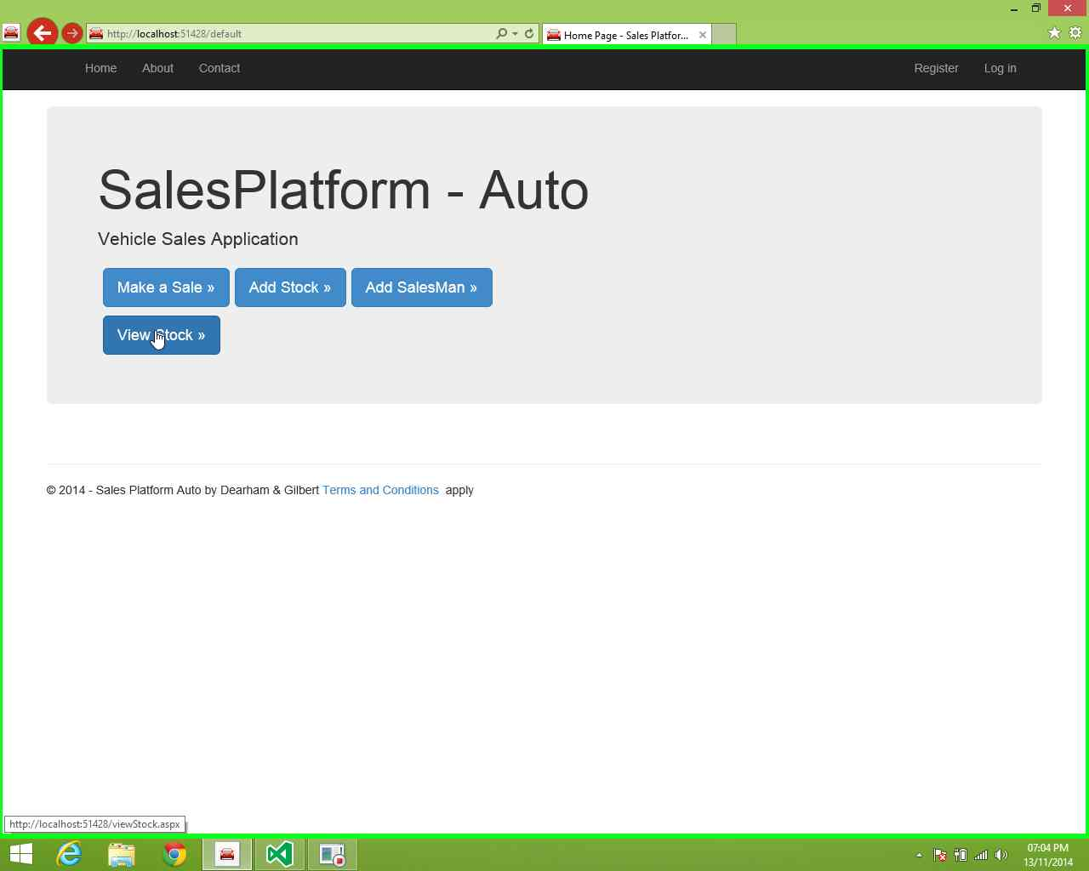

**Step 3:** left click on "Open (button)" in drop-down list of- Sales Platform Auto

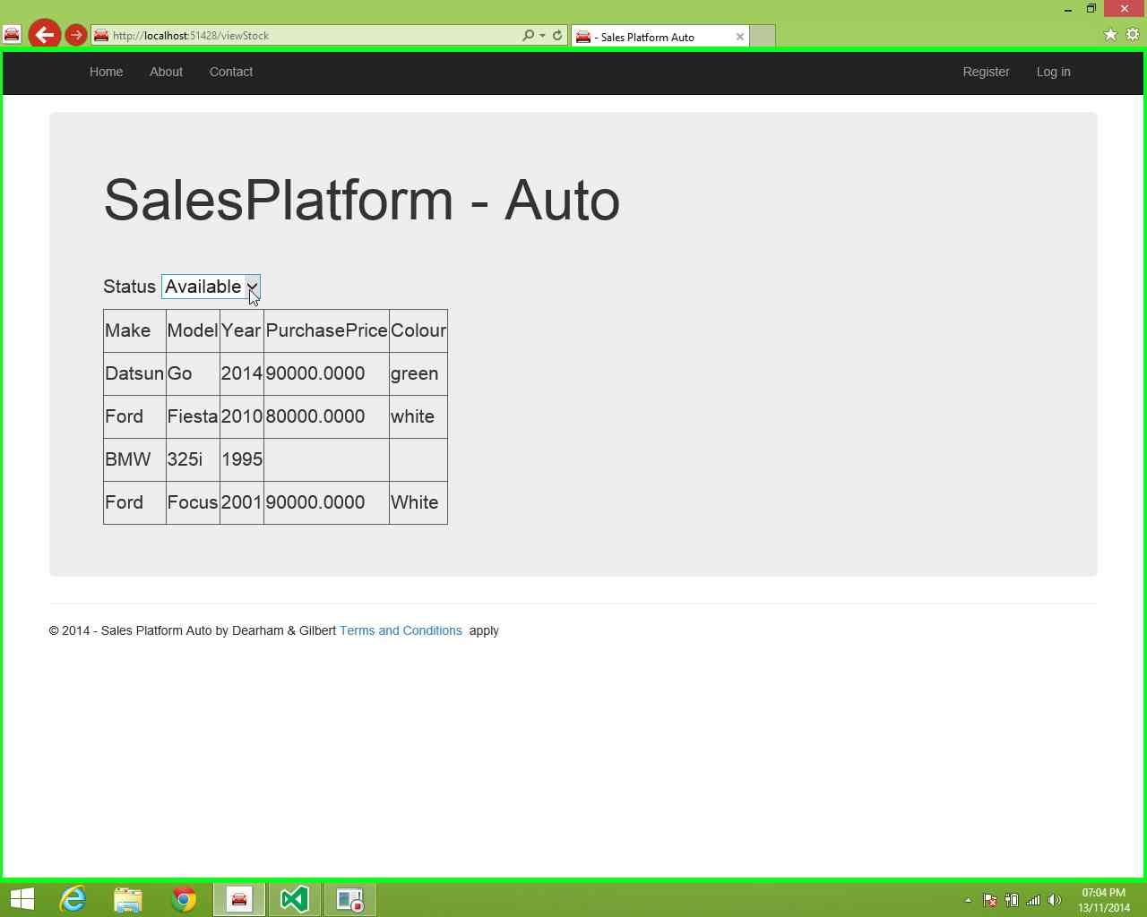

**Step 4:** left click on "Sold (list item)"

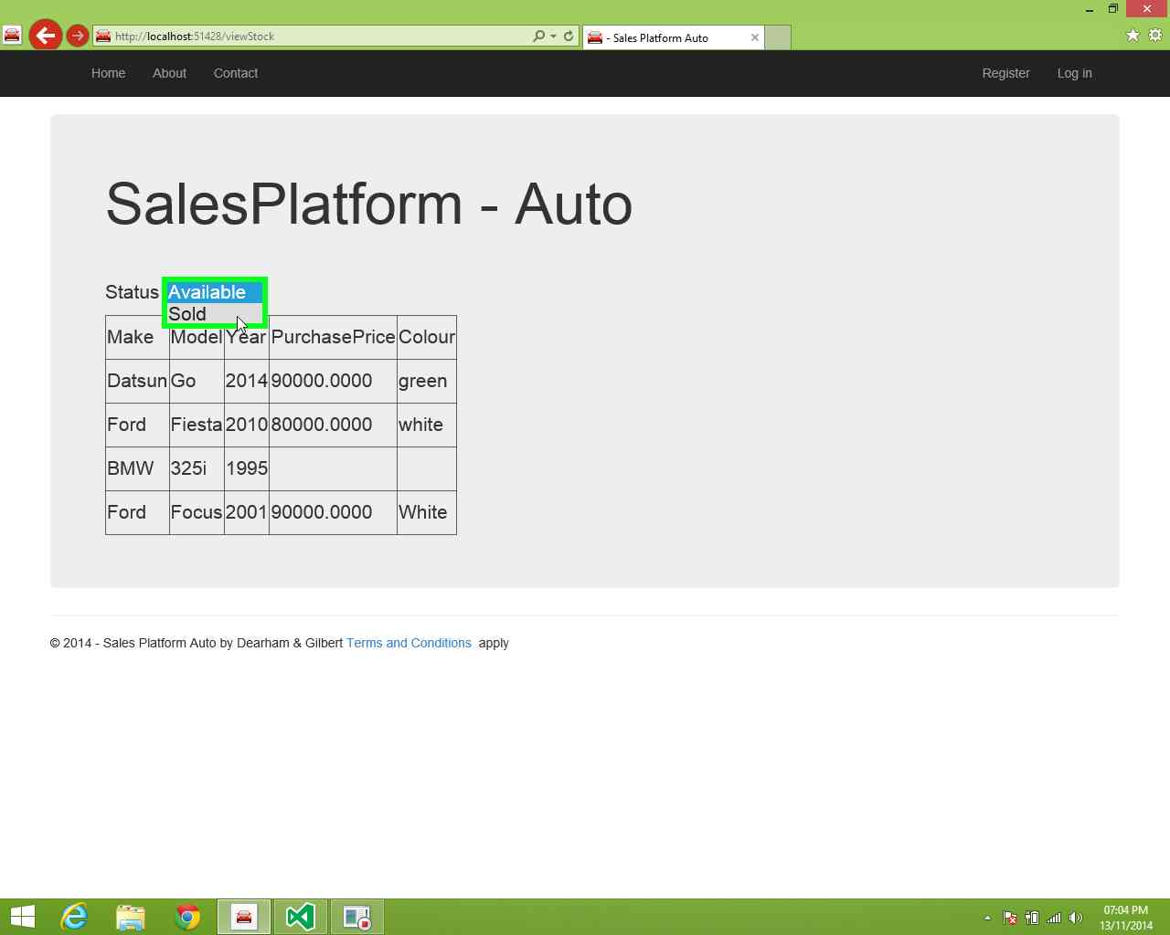

**Step 5:** left click on "Open (button)" in drop-down list of Sales Platform

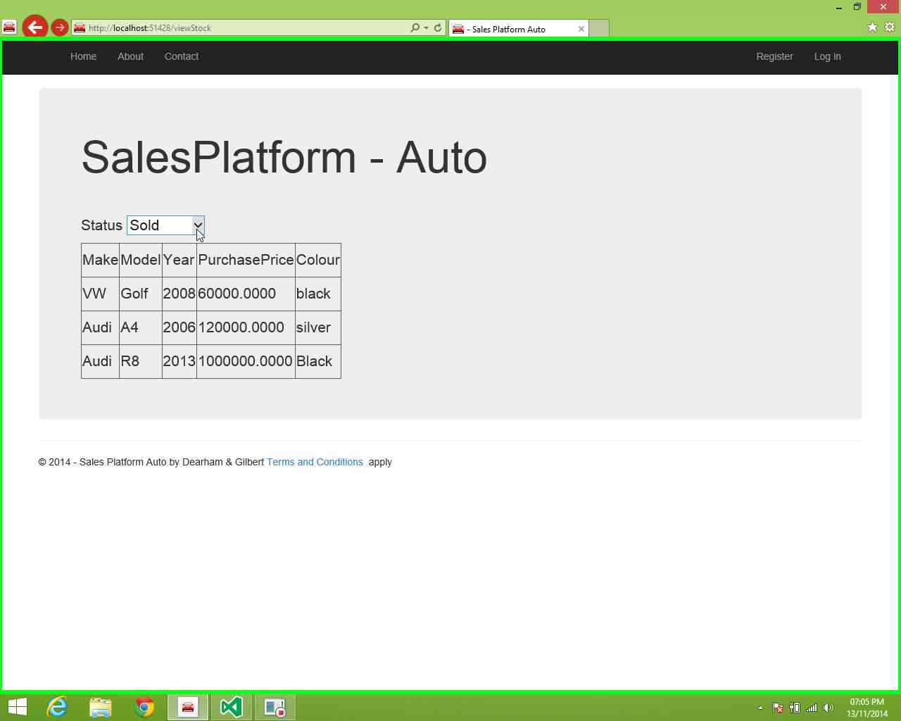

**Step 6:** left click on "Available (list item)"

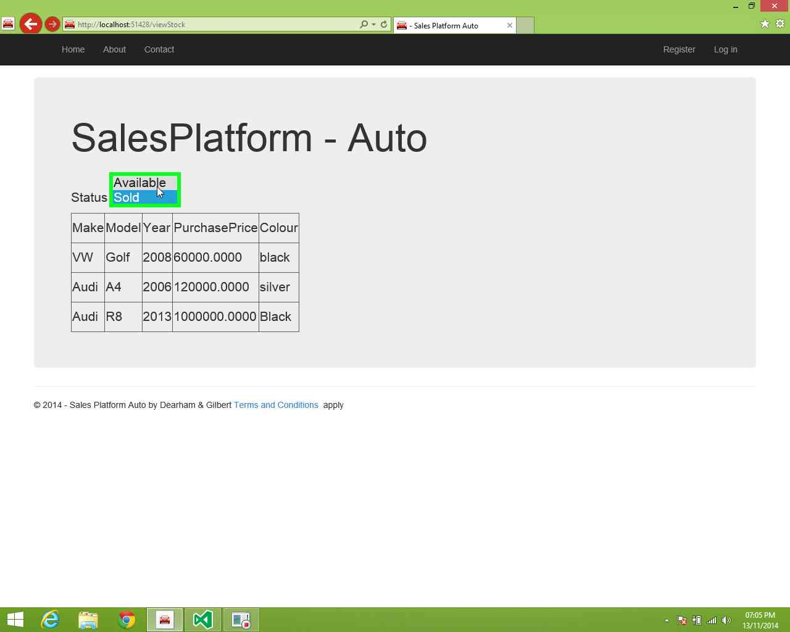

**Step 7:** left click on "Home (link)" in "- Sales Platform Auto

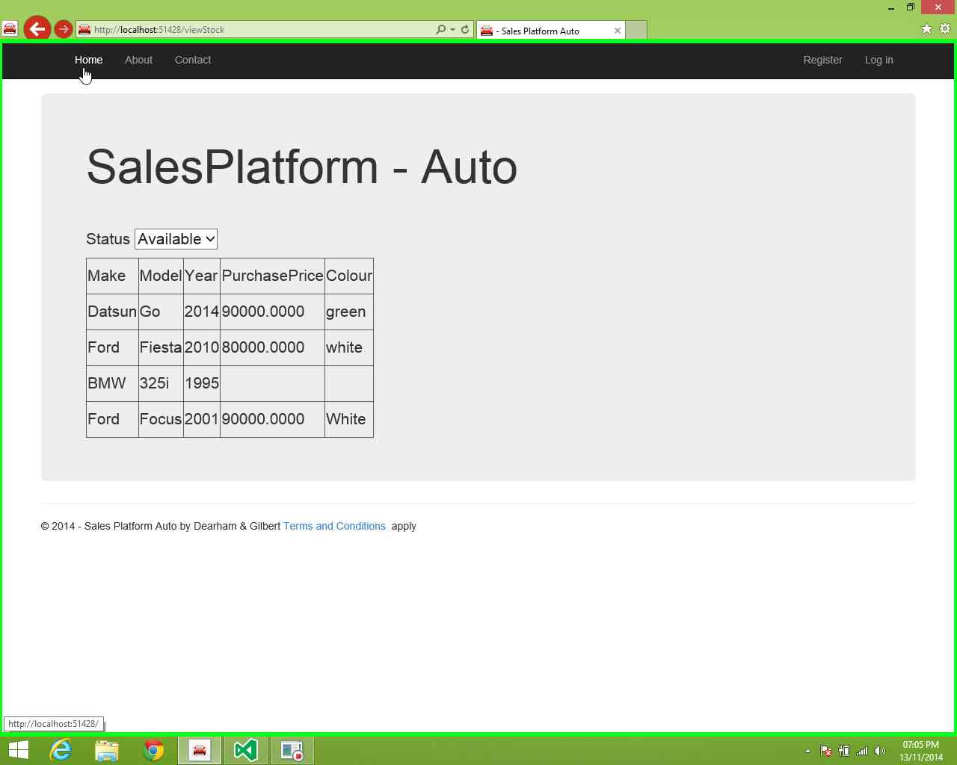

# Problems and solutions

### Login problems

All details and information pertaining to logging into the system and type of authentication required is provided in the **Account** folder below. This will allow problems with passwords to be corrected. The level of authentication desired on the system and assisting locked out users is done here.

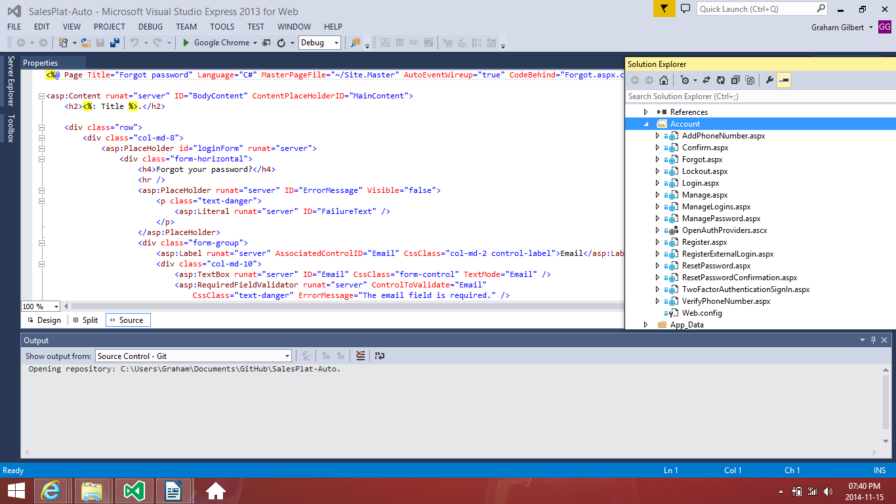

### Time-out problem

If more than 6 users sign in at the same time there could be a situation that the system has a slow response and will at times not respond and time-out. The best way to resolve is simply log out and log back in. If this does not resolve the problem restart the machine.

This could be caused by the ability of the platform it’s being hosted on. A stronger system would result in fewer time-outs.

